**Are online shops killing the distributer-supplier market?**

* In the past a manufacturer used to mass-produce products and sell them in bulk to retailers(or distributers) who in turn where in touch with the consumers and provided them the necessary experience and services while purchasing these products from the retail market.
* The wholesale market and the retail market had different boundaries in which they operated. However, due to the sudden uprising of the online retailing and drop-shipping has changed this scenario to a degree which have turned the manufacturers to active competitors in the retail market.
* The sudden overturn of the traditional methods has put retail in a precarious position. Now the retail is loosing its efficiency in functioning of its economic model of revenue and profitability, and the suppliers engaged in business is showing considerable decline in business that is feared to prove fatal for the retail market.
* The default habit of people to go to a physical store is rapidly disappearing as online stores are fulfilling the same by meeting our shopping needs with remarkable satisfaction. Thus, what could be achieved previously by physical stores can now be done from within the confines of our homes, while on the move from our cell phones, and have anything we desire to buy be at our threshold conveniently from innumerable online shopping websites.

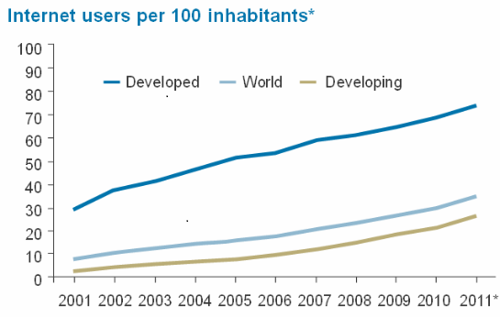

Fig:  figure showing the increasing rate of Internet users from 2001 to 2011. This high level of internet penetration coupled with a generation brought up online and familiar with the digitally connected lifestyle is  increasing the craze of online shopping

* **The Store As The Mass Medium**

Physical stores holds a rather prominent position for the consumers and the current trend of online shopping cannot by any means put an end to the state of physical stores but rather push it towards accepting varied methods of connecting with their consumers. It is believed that the physical stores has the potential to reach out widely and effectively across multitude of people, to form a special kind of bond with its consumers and imbed in the buyers the experience only a physical store can offer. This can act as an powerful tool which if utilized expertly can prove to be something unique in the minds of the consumers and ultimately serve as challenge for the online sellers.

* **Trend Sets the New Rules**

Retailers must accept the current shift in and take appropriate actions to survive using new methods that enable them to main their stronghold as the primary selling destination for buyers. Retailers that make it in this digital age, will be those that defy the traditional methods and come up with new options in the age old industry.

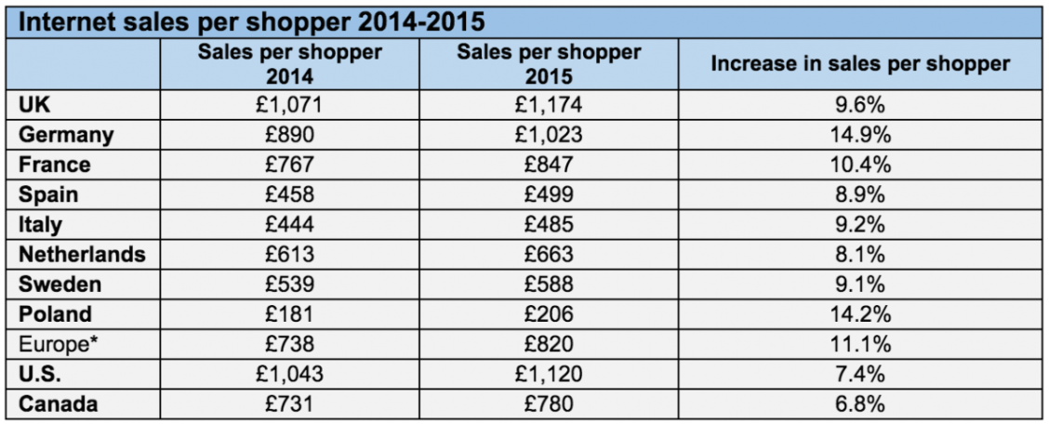

**Fig: Table showing increasing rate of sales in internet shopping**

* In order to stay in the competition against online vendors, they must focus on their unique and favourable characteristics that brings new value to their equation. The following high valued points may provide them with the necessary power to maintain their stand:
* High productivity
* Growth potential
* Efficient layouts
* Positive competitive dynamics
* High shopper traffic
* These characteristics are monumental for retailers to ensure that their business perform. Ultimately, retailers must have a clear understanding of the value they are creating. If retailers can create such characteristics within themselves they will regain their identity that they once held in these ever changing platform. If they do not they are sure to dissolve in the current digital era.